Robotics Studio 4: Quadrotor three

|  |  |
| --- | --- |
| Tanach Chinbutarnont ID 62340500026 | Nattasit Phaisalrittiwong ID 60340500063 |
| Pakapak Silpapinun ID 62340500042 |  |
| **Advisor** – Pi Thanacha Choopojcharoen |  |

**I. Introduction**

The quadrotor is a four-rotor Unmanned Aerial Vehicle (UAV), which contains of four rigidly attached rotors on the vehicle. Due to its unique rotor’s configuration, a control scheme for quadrotor can be synthesized to maneuver with four degrees of freedom. This maneuverability helps users accomplishing desired tasks in dangerous or inaccessible environment. To gain better understanding of control scheme and its application, our team proposes a project on simulating the physics and behavior of the quadrotor.

The scope of this project consists of the following:

1. The entire system will be developed only in computer-simulated environment.
2. The goal of the quadrotor is to vary its altitude and yaw angle, while maintaining minimum change in lateral position.
3. The input from the user interface is the desired altitude and forward direction of the quadrotor.
4. The control scheme provides 3-dimentional resultant torque and force along the rotational axis of the quadrotor.
5. All physical parameters of the quadrotor are constant and known.
6. At least two sensor types are equipped on the quadrotor: 6-axis IMU (3-axis accelerometer; and 3-axis gyroscope) and range sensor.
7. The simulation result is visualized as the movement in a 3D plane; graphs of position signal and rotation signal are plotted against time.

The model of the quadrotor consists of two main parts: dynamics and kinematics model. The kinematics model equation was constructed in the body frame, while state-space representation is in the global coordinate frame. The controlling system of the quadrotor divides into three subsystems: attitude control, altitude control, and lateral flight control [1]. Sensor models are added to the model to create the closed-loop system. In the physical system, many uncertainties occur, such as model error and disturbance of surroundings. Therefore, the state estimation is required[1].

**II. Quadrotor Model & Control System**

To understand the essence of the quadrotor, we firstly created the quadrotor model and identified its control scheme.

1. *Kinematic Model of Quadrotor*

We utilized the knowledge of FRA333, kinematics, to find the pose and rotation matrix of the quadrotor.

* Rotation (Euler’s Angle)

To control the orientation of the quadrotor, we used Z-Y-X Euler angles to model its rotation in the global frame. In this report, the global frame, G, is defined by axes ${\hat{x}}_{G}, {\hat{y}}_{G}, {\hat{z}}_{G}$   with ${\hat{z}}_{G}$ pointing upward [1]. The Body frame, B, is attached to the center of the mass of the quadrotor with ${\hat{x}}_{B}$ pointing in the quadrotor forward direction and ${\hat{z}}_{B}$ perpendicular to the plane of rotors. Therefore, the rotation matrix transforming the global frame to the body frame is given by equation 3,

$R_{G}^{B}= \left[\begin{matrix}c_{ψ}c_{θ} & c_{ψ}s_{θ}s_{ϕ}-c_{ϕ}s_{ψ} & c_{ψ}s_{θ}c_{ϕ}+s_{ψ}s_{ϕ} \\ s_{ψ}c_{θ} & s_{ψ}s_{θ}s_{ϕ}+c_{ϕ}c_{ψ} & s_{ψ}s_{θ}c_{ϕ} -c_{ψ}s_{ϕ} \\ -s_{θ} & c_{θ}s_{ϕ} & c_{θ}c_{ϕ}\end{matrix}\right]$ (3)

where $ψ$ is yaw angle, $θ$ is pitch angle, $ϕ$ is roll angle, and $c_{ϕ}$ and $s_{ϕ}$ denote $\cos\left(ϕ\right)and\sin\left(ϕ\right)$.

Nevertheless, describing orientation in Z-Y-X Euler angles creates singularity issues and complexity while changing the frame reference. Therefore, besides the rotation matrix, all angular variables are in quaternion in this report.

* Orientation Kinematics (Quaternion)

From the research [1], the derivative of quaternion is given by the equation 1.

$\frac{d}{dt}q=\left[\begin{matrix}-q ∙ω \\ q_{0} ω+q_{v}×ω\end{matrix}\right]$ (1)

The quaternion of the quadrotor can be found by integrating the derivative of quaternion as in figure 1.

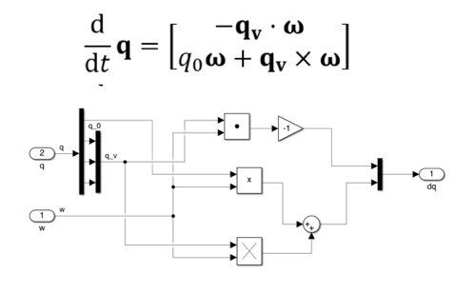

**Figure 1:** block orientation kinematic

Then, the integration was applied to find the quaternion.

* Position Kinematics

Likewise in angular position, the linear position can be found by integrating the input linear velocity.

1. *Dynamics Model of Quadrotor*

From the kinematics equation, the velocity must identify to find the pose of the quadrotor. The inputs of our quadrotor model are torque and force, respecting to global and body frame, respectively. Therefore, before applying the dynamics equation, the input force is transformed into the body frame by a rotation matrix in equation 3.

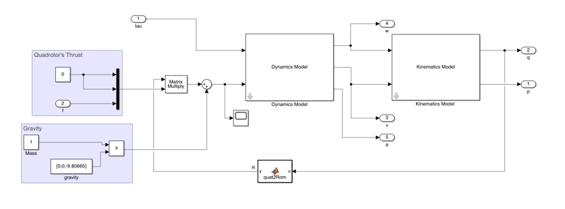

**Figure 2:** the overview of the quadrotor model

* Orientation Dynamics

The orientation dynamics of quadrotor can be described as equation 1.

$$I\dot{ω}= -ω×Iω+ \sum_{i}{τ_{i}}$$

$\frac{d}{dt}ω=I^{-1}(-ω×Iω+\sum_{i}{τ_{i}})$ (2)

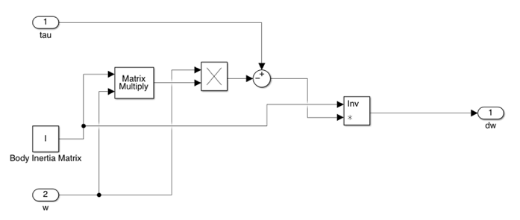

**Figure 3:** the Orientation Dynamics block

Then, the integration was applied to find the angular velocity.

* Position Dynamics

For the position dynamics of quadrotor, the linear acceleration, is calculated by using Newton’s second Law of motion.

$m\dot{v}= \sum_{i}{F_{i}}$

$\frac{d}{dt}\dot{v}=\frac{\left(\sum_{i}{F_{i}}\right)}{m}$ (3)

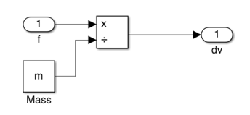

**Figure 4:**  the Position Dynamics block

Then, the integration was applied to find the linear velocity.

1. *Control System*

To control the created model, applied torque and force are calculated.

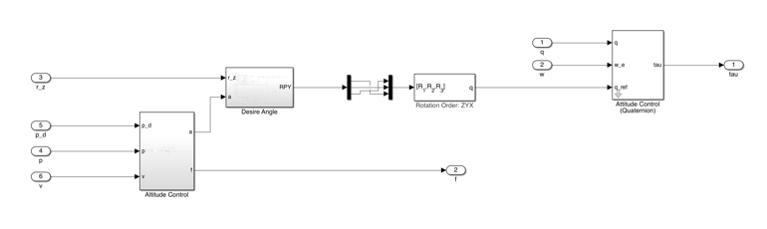

**Figure 5:** the overview of the hover control

* Lateral Flight

In this report, the quadrotor flight was controlled by a quintic polynomial trajectory leading to slight changes in position in the earliest stage. These insignificant changes will allow attitude control to perform synchronously with altitude control.

$s\left(t\right)=C_{0}+C_{1}t+C_{2}t^{2} +C_{3}t^{3} +C_{4}t^{4} +C_{5}t^{5}$

$$\frac{d}{dt}s\left(t\right)=v(t)=C_{1}+{2C}_{2}t +{3C}_{3}t^{2} +{4C}_{4}t^{3} +5C_{5}t^{4}$$

$$\frac{d}{dt}v\left(t\right)=a\left(t\right)={2C}_{2} +{6C}_{3}t +{12C}_{4}t^{2} +{20C}_{5}t^{3}$$

$t_{f}=\sqrt{\frac{10(s_{final}-s_{start})}{a_{max}{\sqrt{3}}}}$

$C_{3}=$ $\frac{10(s_{final}-s_{start})}{t_{f}^{3}}$

$$C_{4}=-\frac{15(s_{final}-s_{start})}{t_{f}^{4}}$$

$C_{5}=$ $\frac{6(s_{final}-s_{start})}{t_{f}^{5}}$

where, $C_{0}$ is the initial position

$C_{1}$ is the initial velocity

$C_{2}$ is the initial acceleration

$s_{final}$ is the desired position

$s_{start}$ is starting position

$a_{max}$ is the maximum acceleration

* Altitude Control

To control the applied force, we control it through acceleration. PID controller was applied to control the desired acceleration from the position error, $∆\vec{p}={\vec{p}}_{d}-\vec{p}$.

$a_{d}=K_{p}∆\vec{p}+K_{i}\int{∆\vec{p}}dt+K_{d}(-\vec{v})$ (4)

where, ${\vec{p}}_{d}$ is a desired position vector.

$\vec{p}$ is a current position vector.

$\vec{v}$ is a current velocity vector.

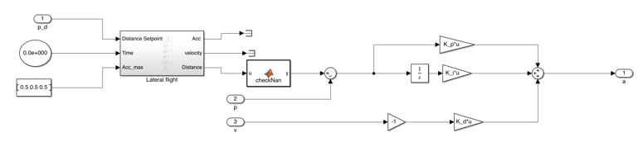

**Figure 6:** the overview of Altitude Control block

* Attitude Control

The result of attitude control is desired torque with the orientation as the input. According to the project’s scope, yaw value has already inputted through the desired forward direction. Linearization applies to equation 5 to find roll and pitch.

$m\left[\begin{matrix}a_{x} \\ a_{y} \\ a_{z}\end{matrix}\right]=R_{G}^{B}\left[\begin{matrix}0 \\ 0 \\ mg\end{matrix}\right]$ (5)

**Linearization**

$$a_{x}= {(c}_{ψ}θ+s_{ψ}ϕ)g$$

$$a_{y}=\left(s_{ψ}θ-c_{ψ}ϕ\right)g$$

$$ϕ=\frac{a_{x}}{g}s_{ψ}-\frac{a_{y}}{g}c_{ψ}$$

$$θ=\frac{a_{x}}{g}c_{ψ}+\frac{a_{y}}{g}s_{ψ}$$

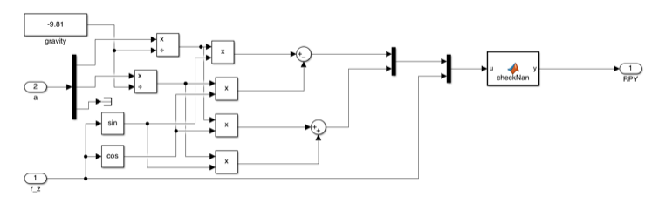

**Figure 7:** the overview of Desire Angle block

The quaternion-based attitude control is used, where $∆q$ and $∆ω$ are the quaternion error and angular velocity error, respectively.

$$∆q=q_{d}⨂\overline{q}$$

$$∆q= \left[\begin{matrix}q_{e,0} \\ q_{e,v}\end{matrix}\right]$$

$τ^{B}=K_{q}×q_{e,v}+K_{ω}(∆ω)$ (6)

**Figure 8:**  the overview of Attitude Control Block

**III. Sensor Model & State-Space Estimation**

In the real physical system, all dependent variables are inputted from sensor, which leads to the occurrence of uncertainties.

1. *Sensor Model*

In this report, three sensor types are equipped on the quadrotor: 6-axis IMU (3-axis accelerometer; and 3-axis gyroscope), magnetometer and range sensor (ultrasonic).

* Ultrasonic Sensor

Due to the possibilities of rotation in roll and pitch, the sensor equation can be described as follow,

$\vec{p}$*= $R_{y}R_{x}{\vec{p}}_{u}$*

$R_{y}R_{x}=$ $\left[\begin{matrix}c_{θ} & 0 & s_{θ} \\ 0 & 1 & 0 \\ -s_{θ} & 0 & c_{θ}\end{matrix}\right]\left[\begin{matrix}1 & 0 & 0 \\ 0 & c_{ϕ} & -s_{∅} \\ 0 & s_{ϕ} & c_{∅}\end{matrix}\right]$

$$\vec{p}= \left[\begin{aligned}p_{x} \\ p_{y} \\ p_{z}\end{aligned}\right]=\left[\begin{matrix}c_{θ} & s_{θ}s_{∅} & c_{∅}s_{θ} \\ 0 & c_{∅} & -s_{∅} \\ -s_{θ} & s_{∅}c_{θ} & c_{∅}c_{θ}\end{matrix}\right]{\vec{p}}_{u}$$

Ultrasonic measures the length along its z axis. Therefore, the ultrasonic measured distance, $Z_{u}$, can be calculated as in equation 7.

$$\vec{p}= \left[\begin{matrix}c_{θ} & s_{θ}s_{∅} & c_{∅}s_{θ} \\ 0 & c_{∅} & -s_{∅} \\ -s_{θ} & s_{∅}c_{θ} & c_{∅}c_{θ}\end{matrix}\right]\left[\begin{aligned}0 \\ 0 \\ Z_{u}\end{aligned}\right]$$

$$\vec{p}=\left[\begin{aligned}c_{ϕ}s_{θ}Z_{u} \\ -s_{∅}Z_{u} \\ c_{θ}c_{∅}Z_{u}\end{aligned}\right]$$

$Z_{u}=\frac{p_{z}}{c_{θ}c_{∅}}$ (7)

where $\vec{p}$ is the actual position vector along z axis $\left[\begin{aligned}p_{x} \\ p_{y} \\ p_{z}\end{aligned}\right]$

${\vec{p}}_{u}$ is a measured position vector $\left[\begin{aligned}0 \\ 0 \\ Z_{u}\end{aligned}\right]$

$Z_{u}$ is a measured position vector along z axis

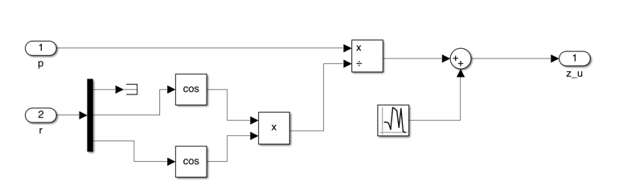

**Figure 9:** ultrasonic sensor model

* Accelerometer

The accelerometer is equipped on the quadrotor, such that the measured acceleration, ${\overset{⃑}{a}}_{a}$, is calculated in the body frame as in the following equation.

${\vec{a}}_{a}=R_{G}^{B}\left(\vec{a}-\left[\begin{matrix}0 \\ 0 \\ g\end{matrix}\right]\right)$ (8)

To find the quadrotor acceleration, $\vec{a}$, the Newton’s second laws is used.

$$ΣF=m\vec{a} \\ {R_{G}^{B}}^{T}F^{B}-m\left[\begin{matrix}0 \\ 0 \\ g\end{matrix}\right]=m\vec{a}$$

$$\vec{a}=\frac{1}{m}\left({R_{G}^{B}}^{T}{\vec{F}}^{B}-m\left[\begin{matrix}0 \\ 0 \\ g\end{matrix}\right]\right)$$

Therefore,

$${\vec{a}}_{a}=R_{G}^{B}\left(\frac{1}{m}\left({R_{G}^{B}}^{T}{\vec{F}}^{B}+m\left[\begin{matrix}0 \\ 0 \\ -g\end{matrix}\right]\right)-\left[\begin{matrix}0 \\ 0 \\ -g\end{matrix}\right]\right)$$

${\vec{a}}_{a}=\left[\begin{matrix}X_{a} \\ Y_{a} \\ Z_{a}\end{matrix}\right] =\frac{1}{m}F^{B}=\frac{1}{m}\left[\begin{matrix}0 \\ 0 \\ T\end{matrix}\right]$ (9)

where, ${\vec{a}}_{a}$ is measured acceleration $\left[\begin{matrix}X_{a} \\ Y_{a} \\ Z_{a}\end{matrix}\right]$

$\vec{a}$ is a quadrotor generated acceleration vector

${\vec{F}}^{B}$ is a propellers’ generated force $\left[\begin{matrix}0 \\ 0 \\ T\end{matrix}\right]$

$T$ is a propellers’ generated thrust

$Z_{a}$ is a measured acceleration along z axis

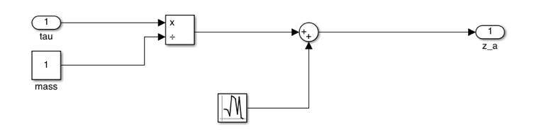

**Figure 10:** accelerometer model

* Gyroscope Sensor

Due to the quadrotor model, the torque will only apply around z axis, therefore the measured angular velocity around z axis, $Z_{g}$, is quadrotor angular velocity around z axis, $ω$.

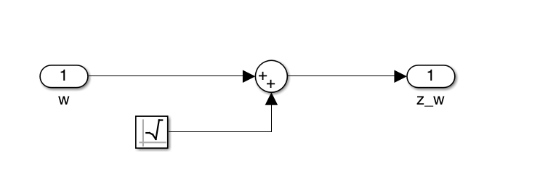

**Figure 11:** gyroscope model

* Magnetometer

For orientation control feedback, the magnetometer is used. Due to the work of magnetometer, measuring the size of the north magnetic field in body frame, the measured magnetic field can be calculated as the following equation [2] (11).

${\vec{Z}}_{m}=\left[\begin{matrix}Z_{m,x} \\ Z_{m,y} \\ Z_{m,z}\end{matrix}\right]=R_{G}^{B}\left[\begin{matrix}0 \\ 1 \\ 0\end{matrix}\right]$ (11)

where ${\vec{Z}}_{m}$ is a measured magnetic field $\left[\begin{matrix}Z_{m,x} \\ Z_{m,y} \\ Z_{m,z}\end{matrix}\right]$

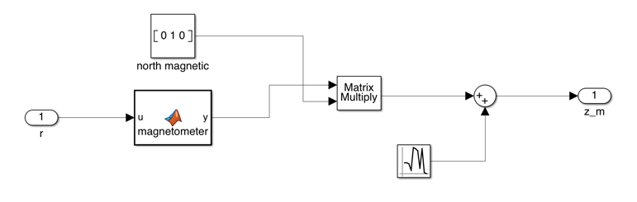

**Figure 12:** magnetometer model

Thus,

$\left[\begin{matrix}\begin{aligned} {\vec{Z}}_{u} \\ {\vec{Z}}_{a} \\ {\vec{Z}}_{g}\end{aligned} \\ {\vec{Z}}_{m}\end{matrix}\right]=\left[\begin{matrix}\begin{aligned}\frac{{\overset{⃑}{P}}_{z}}{c_{θ}c_{∅} } \\ \frac{1}{m}\left[\begin{aligned}0 \\ 0 \\ T\end{aligned}\right] \\ \vec{ω}\end{aligned} \\ R_{G}^{B}\left[\begin{matrix}0 \\ 1 \\ 0\end{matrix}\right]\end{matrix}\right]$ (10)

1. *Estimator*

The estimator constructs with 2 main parts: position estimator and orientation estimator. In position estimation, the Kalman Filter is used to estimate the quadrotor’s position, while the Extended Kalman Filter is used to estimate the orientation.

* Position Estimator

The estimation of position, velocity, and acceleration equation is in the discrete-time domain. The Kalman Filter can be described in equation 11.

$\overset{⃑}{x}\left[k+1\right]=A\vec{x}\left[k\right]+B\vec{u}\left[k\right]+G\vec{w}[k]$

$\overset{⃑}{y}\left[k\right]=C\vec{x}\left[k\right]+D\vec{u}\left[k\right]+\vec{V}[k]$ (11)

where, $\vec{x}$ is a state of the quadrotor

$\vec{u}$ is a input of the quadrotor $\vec{y}$ 
 is a output of the quadrotor

$\vec{w}$ is a process noise of the quadrotor

$\vec{v}$ is a measurement noise of the quadrotor

$A,B,C$ and $D$ are parameters

After the all related equations and parameters are identified (Appendix B), we apply the Kalman filter into the system by using the Kalman filter block with the calculated parameters and set the sample rate to 100 Hz.

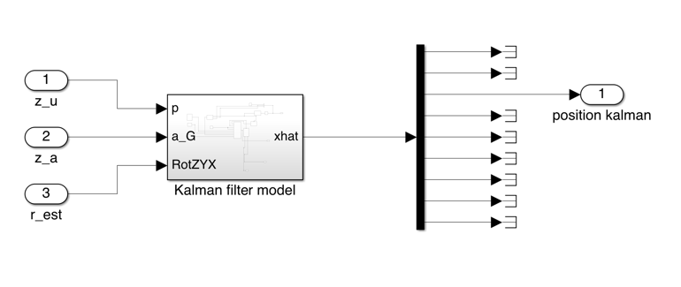

**Figure 13** position estimator block

* Orientation Estimator

- Euler’s rate $\dot{(r})$

The Euler’s rate of each axis can be calculated by following equations [3]

$$\dot{Z} =\left[\begin{matrix}1 & 0 & 0 \\ 0 & c_{θ} & s_{θ} \\ 0 & -s_{θ} & c_{θ}\end{matrix}\right]\left[\begin{matrix}c_{ϕ} & 0 & -s_{ϕ} \\ 0 & 1 & 0 \\ s_{ϕ} & 0 & c_{ϕ}\end{matrix}\right]\left[\begin{matrix}0 \\ 0 \\ {\dot{r}}_{z}\end{matrix} \right]$$

$$\dot{Y}=\left[\begin{matrix}1 & 0 & 0 \\ 0 & c_{θ} & s_{θ} \\ 0 & -s_{θ} & c_{θ} \end{matrix}\right]\left[\begin{matrix}0 \\ \dot{r_{y}} \\ 0\end{matrix}\right]$$

$$\dot{X}=\left[\begin{matrix}\dot{r_{x}} \\ 0 \\ 0\end{matrix}\right]$$

$ω= \left[\begin{matrix}1 & 0 & -s_{θ} \\ 0 & c_{ϕ} & s_{ϕ}c_{θ} \\ 0 & -s_{ϕ} & c_{ϕ}c_{θ}\end{matrix}\right]\left[\begin{matrix}\dot{r_{x}} \\ \dot{r_{y}} \\ \dot{r_{z}}\end{matrix}\right]$

$$\dot{\vec{r}}=\left[\begin{matrix}1 & s_{ϕ}t_{θ} & c_{ϕ}t_{θ} \\ 0 & c_{ϕ} & -s_{ϕ} \\ 0 & \frac{s_{ϕ}}{c_{θ }} & \frac{c_{ϕ}}{c_{θ}}\end{matrix}\right]ω$$

From $\dot{\vec{r}}=J_{r}\left(r\right)ω$

$$J_{r}\left(r\right)= \left[\begin{matrix}1 & s_{θ}t_{ϕ} & c_{θ}t_{ϕ} \\ 0 & c_{θ} & -s_{θ} \\ 0 & \frac{s_{θ}}{c_{ϕ}} & \frac{c_{θ}}{c_{ϕ}}\end{matrix}\right]$$

Therefore, the state-space model of the quadrotor orientation can be written as these following equations.

$$\vec{ω}\left[k+1\right]= \vec{ω}\left[k\right]+\dot{\overset{⃑}{ω}}\left[k\right]Δt+\frac{1}{2}\ddot{\overset{⃑}{ω}}[k](Δt^{2})$$

$$\dot{\overset{⃑}{ω}}\left[k+1\right]=\dot{\overset{⃑}{ω}}\left[k\right]+\ddot{\overset{⃑}{ω}}\left[k\right]⋅Δt$$

$$\vec{r}\left[k+1\right]=J_{r}\left(\vec{r}\left[k\right]\right)\left(\vec{ω}\left[k\right]+ \dot{\overset{⃑}{ω}}\left[k\right]⋅Δt+\frac{1}{2}\ddot{\overset{⃑}{ω}}\left[k\right]Δt^{2}\right)⋅Δt+\vec{r}[k]$$

From those equations, they are a non-linear equation. Therefore, the Extended Kalman Filter is used to estimate the quadrotor orientation (Appendix C). The estimation of angular velocity and Euler’s angle equation is in the discrete-time domain. The Extended Kalman Filter can be described in equation 12. To apply the extended Kalman filter, we used the extended Kalman filter block. The sample rate of the extended Kalman filter block is 100 Hz.

$\overset{⃑}{x}\left[k+1\right]=f(\overset{⃑}{x}\left[k\right],\overset{⃑}{u}\left[k\right],\vec{w}\left[k\right]$)

$\vec{y}\left[k\right]=g\left(\overset{⃑}{x}\left[k\right],\overset{⃑}{u}\left[k\right]\right)+\overset{⃑}{v}\left[k\right]$ (12)

where, $\vec{x}$ is a state of the quadrotor

$\vec{u}$ is a input of the quadrotor $\vec{y}$ 
 is a output of the quadrotor

$\vec{w}$ is a process noise of the quadrotor

$\vec{v}$ is a measurement noise of the quadrotor

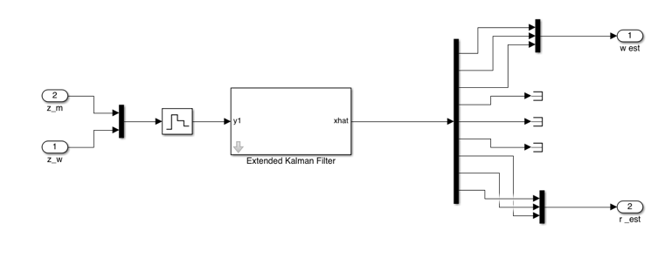

**Figure 14:** orientation estimator block

To observe the behavior of simulated quadrotor, we create the block storing all calculated quadrotor moving position into MATLAB workspace, simout plot, to visualize it in MATLAB 3D plot.

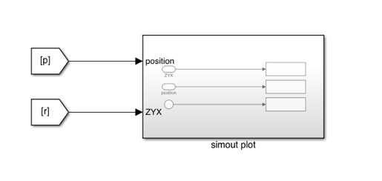

**Figure 15:** quadrotor model

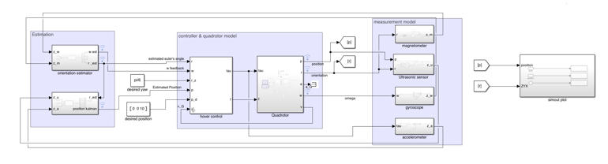

**Figure 16:** overview of the quadrotor model with feedback control

1. *Implementation*

To observe the result, we connect all blocks and observe the simulated result: position, Euler’s angle, and angular velocity, via data inspector. To test the performance of the estimator and control scheme, the noise with 0.01 variance and 0 mean is added into all sensor models. The result of the simulation is shown in figure 17 (position), 18 (angular velocity),19 (Euler’s angle rate), and 20 (the overview of the quadrotor behavior).

**Figure 17:** the graph shows the position along z axis after adding noise into the system. (purple: measured position, orange: estimated position)

* Orientation Control and Estimation

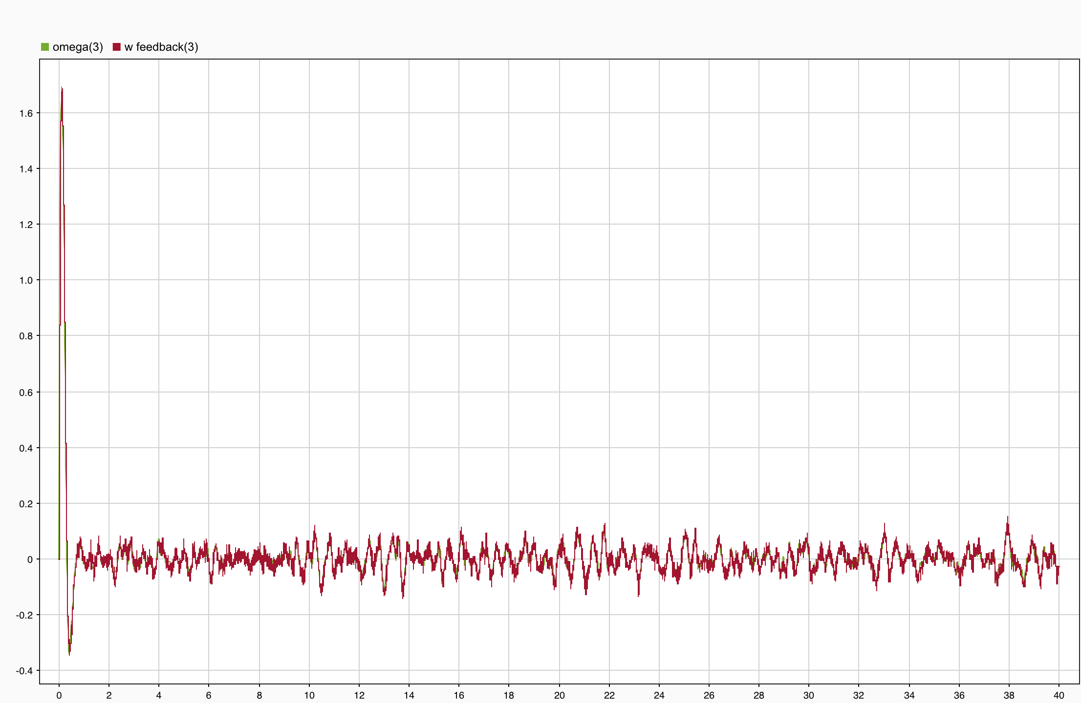

**Figure 18:** the graph shows the changing of angular velocity along z axis after adding noise into the system. (green: measured angular velocity, red: estimated angular velocity)

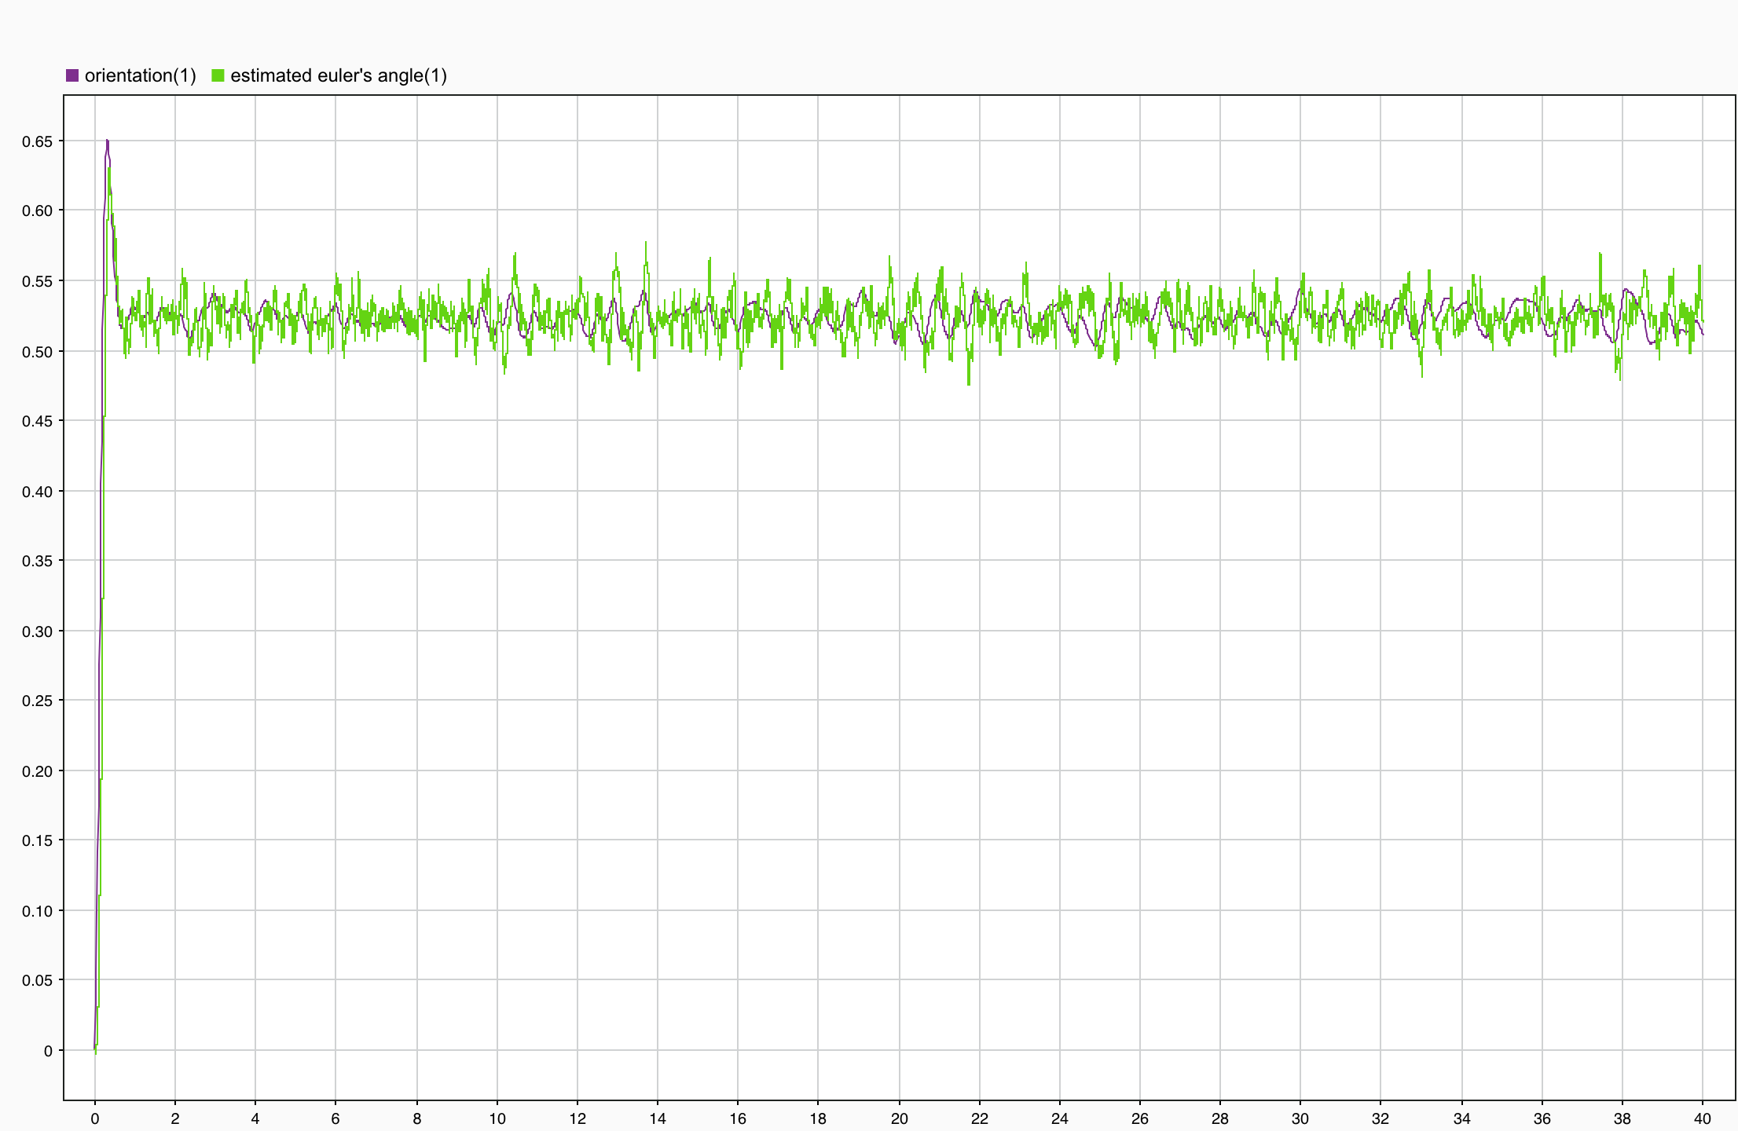

**Figure 19:** the graph shows the changing of Euler’s angle along z axis after adding noise into the system. (purple: measured Euler’s angle, green: estimated Euler’s angle)

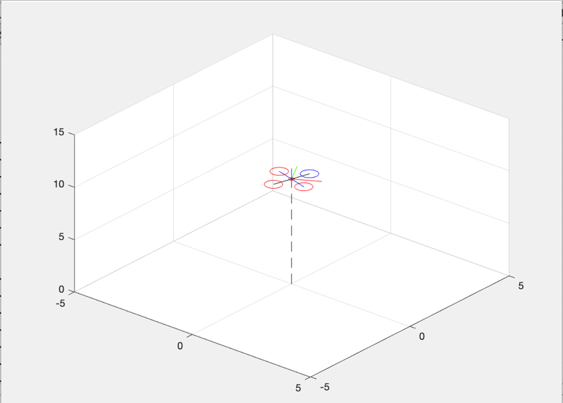

**Figure 20:** the visualization of quadrotor movement in a 3D plane

**Appendix A: Position State-Space Identification**

From $\overset{⃑}{a}=\frac{1}{m}R_{B}^{G}$ $\left[\begin{aligned}0 \\ 0 \\ T+d\end{aligned}\right]+$ $\left[\begin{aligned}0 \\ 0 \\ -g\end{aligned}\right]$

$\overset{⃑}{a}\left[k\right]=\frac{1}{m}R(\overset{⃑}{r}[k] )$ $\left[\begin{aligned}0 \\ 0 \\ T+d\end{aligned}\right]+$ $\left[\begin{aligned}0 \\ 0 \\ -g\end{aligned}\right]$

where, $\overset{⃑}{a}$ is the acceleration

$\overset{⃑}{a}[k]$ is the discrete-time acceleration

$m$ is mass

$R_{B}^{G}$ is the rotation matrix from Body-frame to Global-frame

$R(\overset{⃑}{r}[k] )$ is the discrete-time rotation matrix from Body-frame to Global-frame

$T$ is thrust

$g$ is gravity

Because of $\frac{d\overset{⃑}{v} }{dt}= \overset{⃑}{a}$

$\int_{τ=0}^{t}{(\frac{d\overset{⃑}{v} }{dt})}$*d $τ$*= $\int_{τ=0}^{t}{(\overset{⃑}{a} )}$ *d $τ$*

$\overset{⃑}{v}\left(t\right) = \overset{⃑}{v}(0)$ $+\overset{⃑}{a}(t)$

at $t=t_{k}$

$\overset{⃑}{v}\left(t_{k}\right)= \overset{⃑}{v}(0)$ $+\overset{⃑}{a}(t_{k})$

$\overset{⃑}{v}[k]$ $=\overset{⃑}{v}[0]$ $+\overset{⃑}{a}[k]{(t}_{k})$

at $t_{k+1}=$ $t_{k}$ $+∆t$

$\overset{⃑}{v}\left(t_{k+1} \right) = \overset{⃑}{v}\left(0\right)+$ $\overset{⃑}{a}{(t}_{k+1})$

$\overset{⃑}{v}\left[k+1\right]=$ $\overset{⃑}{v}\left[0\right]+$ $\overset{⃑}{a}[k]{(t}_{k+1})$

$\overset{⃑}{v}\left[k+1\right]=$ $\overset{⃑}{v}\left[0\right]+$ $\overset{⃑}{a}[k](t_{k}+$ $∆t)$

$\overset{⃑}{v}\left[k+1\right]=$ $\overset{⃑}{v}\left[k\right]+ \overset{⃑}{a}[k]∆t$ (1)

Replace $\overset{⃑}{a}\left[k\right]= \frac{1}{m}R(\overset{⃑}{r}[k] )$ $\left[\begin{aligned}0 \\ 0 \\ T+d\end{aligned}\right]+$ $\left[\begin{aligned}0 \\ 0 \\ -g\end{aligned}\right]$ in equation (1)

$\overset{⃑}{v}\left[k+1\right]=$ $\overset{⃑}{v}\left[k\right]$ + $\frac{∆t}{m}R(\overset{⃑}{r}[k] )$ $\left[\begin{aligned}0 \\ 0 \\ T+d\end{aligned}\right]+\left[\begin{aligned}0 \\ 0 \\ -g\end{aligned}\right]∆t$

Because of $\frac{d\overset{⃑}{p} }{dt}= \overset{⃑}{v}$

$\int_{τ=0}^{t}{\left(\frac{d\overset{⃑}{p} }{dt}\right)dτ } =\int_{τ=0}^{t}{(\overset{⃑}{v} )}$ $dτ$

= $\int_{τ=0}^{t}{(\overset{⃑}{v}(0) + \overset{⃑}{a}(t) )}$ *d $τ$*

= $\int_{τ=0}^{t}{(\overset{⃑}{v}\left(0\right))dτ + \int_{τ=0}^{t}{(\overset{⃑}{a}(t) })}$ $dτ$

$p\left(t\right) =\overset{⃑}{p}\left(0\right)+\overset{⃑}{v}\left(0\right)t+\frac{\overset{⃑}{a}t^{2}}{2}$

at $t=t_{k}$

$\overset{⃑}{p}\left(t_{k}\right) =$ $\overset{⃑}{p}\left(0\right)+\overset{⃑}{v}\left(0\right)t_{k}+$ $\frac{\overset{⃑}{a}{t_{k}}^{2}}{2}$

$\overset{⃑}{p}\left[k\right] =$ $\overset{⃑}{p}\left[0\right]+ \overset{⃑}{v}\left[0\right]t_{k}+\frac{\overset{⃑}{a}[k]{t_{k}}^{2} }{2}$

at $t_{k+1}=$ $t_{k}+$ $∆t$

$\overset{⃑}{p}\left(t_{k+1}\right) =$ $\overset{⃑}{p}[k+1]$

$\overset{⃑}{p}[k+1]$ $=\overset{⃑}{p}\left[0\right]+$ $\overset{⃑}{v}\left[0\right]t_{k}+\overset{⃑}{v}\left[0\right]∆t+\frac{\overset{⃑}{a}[k]{t_{k}}^{2}}{2}+\frac{\overset{⃑}{a}[k]{ ∆t}^{2}}{2}+\overset{⃑}{a}[k]t_{k}∆t$

$= \overset{⃑}{p}\left[k\right] + ∆t\left(\overset{⃑}{v}\left[0\right]+\overset{⃑}{a}\left[k\right]t_{k}\right)+\frac{\overset{⃑}{a}[k]{ ∆t}^{2}}{2}$

$\overset{⃑}{p}\left[k+1\right]=\overset{⃑}{p}\left[k\right] +\overset{⃑}{v}\left[k\right]∆t + \frac{\overset{⃑}{a}[k]{ ∆t}^{2}}{2}$ (2)

Replace $\overset{⃑}{a}\left[k\right]= \frac{1}{m}R(\overset{⃑}{r}[k] )$ $\left[\begin{aligned}0 \\ 0 \\ T+d\end{aligned}\right]+$ $\left[\begin{aligned}0 \\ 0 \\ -g\end{aligned}\right]$ in equation (2)

$\overset{⃑}{p}\left[k+1\right]=$ $\overset{⃑}{p}\left[k\right] +\overset{⃑}{v}\left[k\right]∆t +\frac{{∆t}^{2}}{2}(\frac{1}{m}R(\overset{⃑}{r}\left[k\right])\left[\begin{aligned}0 \\ 0 \\ T+d\end{aligned}\right]+\left[\begin{aligned}0 \\ 0 \\ -g\end{aligned}\right] )$

$=\overset{⃑}{p}\left[k\right] + \overset{⃑}{v}\left[k\right]∆t+\left[\begin{aligned}0 \\ 0 \\ -g\frac{{∆t}^{2}}{2}\end{aligned}\right]$ $+\frac{{∆t}^{2}}{2m}R(\overset{⃑}{r}\left[k\right])\left[\begin{aligned}0 \\ 0 \\ T+d\end{aligned}\right]$

Therefore

$\overset{⃑}{p}\left[k+1\right] =$ $\overset{⃑}{p}\left[k\right] + \overset{⃑}{v}\left[k\right]∆t$ $+$ $\left[\begin{aligned}0 \\ 0 \\ -g\frac{{∆t}^{2}}{2}\end{aligned}\right]$ $+\frac{{∆t}^{2}}{2m}R\left(\overset{⃑}{r}\left[k\right]\right)\left[\begin{aligned}0 \\ 0 \\ T\end{aligned}\right]+$ $\frac{{∆t}^{2}}{2m}R(\overset{⃑}{r}[k] )\left[\begin{aligned}0 \\ 0 \\ d\end{aligned}\right]$

$\overset{⃑}{v}\left[k+1\right]=\overset{⃑}{v}\left[k\right]+\frac{∆t}{m}R(\overset{⃑}{r}[k] )$ $\left[\begin{aligned}0 \\ 0 \\ T\end{aligned}\right]+$ $\frac{∆t}{m}R(\overset{⃑}{r}[k] )$ $\left[\begin{aligned}0 \\ 0 \\ d\end{aligned}\right]$ $+\left[\begin{aligned}0 \\ 0 \\ -g∆t\end{aligned}\right]$

$\left[\begin{aligned}\overset{⃑}{p_{x}}\left[k+1\right] \\ \overset{⃑}{p_{y}}[k+1] \\ \overset{⃑}{p_{z}}\left[k+1\right] \\ \overset{⃑}{v_{x}}[k+1] \\ \overset{⃑}{v_{y}}[k+1] \\ \overset{⃑}{v_{z}}[k+1] \\ \overset{⃑}{a_{x}}[k+1] \\ \overset{⃑}{a_{y}}[k+1] \\ \overset{⃑}{a_{z}}[k+1]\end{aligned}\right]$ $=\left[\begin{matrix}I_{3} & ∆t {∙I}_{3} & 0_{3x3} \\ 0_{3x3} & I_{3} & 0_{3x3} \\ 0_{3x3} & 0_{3x3} & 0_{3x3}\end{matrix}\right]\left[\begin{aligned}\overset{⃑}{p_{x}}\left[k\right] \\ \overset{⃑}{p_{y}}[k] \\ \overset{⃑}{p_{z}}\left[k\right] \\ \overset{⃑}{v_{x}}[k] \\ \overset{⃑}{v_{y}}[k] \\ \overset{⃑}{v_{z}}[k] \\ \overset{⃑}{a_{x}}[k] \\ \overset{⃑}{a_{y}}[k] \\ \overset{⃑}{a_{z}}[k]\end{aligned}\right]+$ $\left[\begin{aligned}0 \\ 0 \\ \frac{{∆t}^{2}}{2m}R(\overset{⃑}{r}[k] ) \\ 0 \\ 0 \\ \frac{∆t}{m}R(\overset{⃑}{r}[k] ) \\ 0 \\ 0 \\ \frac{1}{m}R(\overset{⃑}{r}[k] ) \end{aligned}\right]T+$ $\left[\begin{aligned}0 \\ 0 \\ \frac{{∆t}^{2}}{2m}R(\overset{⃑}{r}[k] ) \\ 0 \\ 0 \\ \frac{∆t}{m}R(\overset{⃑}{r}[k] ) \\ 0 \\ 0 \\ \frac{1}{m}R(\overset{⃑}{r}[k] ) \end{aligned}\right]d+\left[\begin{aligned}0 \\ 0 \\ \frac{-{∆t}^{2}}{2} \\ 0 \\ 0 \\ -∆t \\ 0 \\ 0 \\ -1 \end{aligned}\right] \overset{⃑}{g}$

Because of position estimator interest just 2 sensors which are ultrasonic sensor and accelerometer ($Z_{u},Z_{a})$, respectively. The equation can be rewritten it in form of state

From $\left[\begin{aligned}Z_{a} \\ \\ Z_{u}\end{aligned}\right]=$ $\left[\begin{aligned}0 \\ 0 \\ {R_{B}^{G}\overset{⃑}{r}\left[k\right]}^{T}(\overset{⃑}{a_{z}}\left[k\right]- \overset{⃑}{g}) \\ \\ \frac{{\overset{⃑}{P}}_{z}}{c_{θ}c_{∅}}\end{aligned}\right]$

Rearrange them in form of state variables

$\left[\begin{aligned}Z_{a} \\ \\ Z_{u}\end{aligned}\right]=\left[\begin{matrix}0_{3x3} & 0_{3x3} & {R_{B}^{G}(\overset{⃑}{r}\left[k\right])}^{T} \\ 0 0 \frac{1}{c_{θ}c_{∅}} & 0 0 0 & 0 0 0\end{matrix}\right]$ $\left[\begin{aligned}\overset{⃑}{p_{x}}\left[k\right] \\ \overset{⃑}{p_{y}}[k] \\ \overset{⃑}{p_{z}}\left[k\right] \\ \overset{⃑}{v_{x}}[k] \\ \overset{⃑}{v_{y}}[k] \\ \overset{⃑}{v_{z}}[k] \\ \overset{⃑}{a_{x}}[k] \\ \overset{⃑}{a_{y}}[k] \\ \overset{⃑}{a_{z}}[k]\end{aligned}\right]+\left[\begin{aligned}0 \\ 0 \\ -{R_{B}^{G}\left(\overset{⃑}{r}\left[k\right]\right)}^{T}\overset{⃑}{g} \\ 0\end{aligned}\right]$

where, $\overset{⃑}{p_{i}}\left[k+1\right]$ is the next step of i-axis position where i = x, y, z

$\overset{⃑}{v_{i}}\left[k+1\right]$ is the next step of i-axis velocity where i = x, y, z

$\overset{⃑}{a_{i}}\left[k+1\right]$ is the next step of i-axis acceleration where i = x, y, z

$\overset{⃑}{p_{i}}\left[k\right]$ is the discrete-time of i-axis position where i = x, y, z

$\overset{⃑}{v_{i}}\left[k\right]$ is the discrete-time of i-axis velocity where i = x, y, z

$\overset{⃑}{a_{i}}\left[k\right]$ is the discrete-time of i-axis acceleration where i = x, y, z

**Appendix B: Estimation of Kalman Filter’s Parameter**

Rearrange the equation of state and output equation in form of Kalman filter

From $\overset{⃑}{x}\left[k+1\right]=A\vec{x}\left[k\right]+B\vec{u}\left[k\right]+G\vec{w}[k]$ (11)

$\overset{⃑}{y}\left[k\right]=C\vec{x}\left[k\right]+D\vec{u}\left[k\right]+\vec{V}[k]$ (12)

Define $\overset{⃑}{x}\left[k\right]=$ $\left[\begin{aligned}\overset{⃑}{p_{x}}\left[k\right] \\ \overset{⃑}{p_{y}}\left[k\right] \\ \overset{⃑}{p_{z}}\left[k\right] \\ \overset{⃑}{v_{x}}\left[k\right] \\ \overset{⃑}{v_{y}}\left[k\right] \\ \overset{⃑}{v_{z}}\left[k\right] \\ \overset{⃑}{a_{x}}\left[k\right] \\ \overset{⃑}{a_{y}}\left[k\right] \\ \overset{⃑}{a_{z}}\left[k\right]\end{aligned}\right]$ and $\overset{⃑}{u}\left[k\right]=$ $\left[\begin{aligned}u_{1} \\ \\ u_{2}\end{aligned}\right]$

From Output equation, which is sensor equation from Appendix A, it cannot rearrange into the equation which its variables are thrust and gravity. Because sensor equation doesn’t have thrust variables, we must combine them in matrix form, $\overset{⃑}{u}\left[k\right]=$ $\left[\begin{aligned}u_{1} \\ \\ u_{2}\end{aligned}\right]$

Where $u_{1}$ is

$\left[\begin{aligned}\overset{⃑}{p_{x}}\left[k+1\right] \\ \overset{⃑}{p_{y}}[k+1] \\ \overset{⃑}{p_{z}}\left[k+1\right] \\ \overset{⃑}{v_{x}}[k+1] \\ \overset{⃑}{v_{y}}[k+1] \\ \overset{⃑}{v_{z}}[k+1] \\ \overset{⃑}{a_{x}}[k+1] \\ \overset{⃑}{a_{y}}[k+1] \\ \overset{⃑}{a_{z}}[k+1]\end{aligned}\right]=\left[\begin{matrix}I_{3} & ∆t {∙I}_{3} & 0_{3x3} \\ 0_{3x3} & I_{3} & 0_{3x3} \\ 0_{3x3} & 0_{3x3} & 0_{3x3}\end{matrix}\right]\left[\begin{aligned}\overset{⃑}{p_{x}}\left[k\right] \\ \overset{⃑}{p_{y}}[k] \\ \overset{⃑}{p_{z}}\left[k\right] \\ \overset{⃑}{v_{x}}[k] \\ \overset{⃑}{v_{y}}[k] \\ \overset{⃑}{v_{z}}[k] \\ \overset{⃑}{a_{x}}[k] \\ \overset{⃑}{a_{y}}[k] \\ \overset{⃑}{a_{z}}[k]\end{aligned}\right]+$ $\left[\begin{aligned}0 \\ 0 \\ \frac{{∆t}^{2}}{2m}R(\overset{⃑}{r}[k] ) \\ 0 \\ 0 \\ \frac{∆t}{m}R(\overset{⃑}{r}[k] ) \\ 0 \\ 0 \\ \frac{1}{m}R(\overset{⃑}{r}[k] ) \end{aligned}\right]T+$ $\left[\begin{aligned}0 \\ 0 \\ \frac{{∆t}^{2}}{2m}R(\overset{⃑}{r}[k] ) \\ 0 \\ 0 \\ \frac{∆t}{m}R(\overset{⃑}{r}[k] ) \\ 0 \\ 0 \\ \frac{1}{m}R(\overset{⃑}{r}[k] ) \end{aligned}\right]d+\left[\begin{aligned}0 \\ 0 \\ \frac{-{∆t}^{2}}{2} \\ 0 \\ 0 \\ -∆t \\ 0 \\ 0 \\ -1 \end{aligned}\right] \overset{⃑}{g}$

Rearrange the above equation

$\left[\begin{aligned}\overset{⃑}{p_{x}}\left[k+1\right] \\ \overset{⃑}{p_{y}}[k+1] \\ \overset{⃑}{p_{z}}\left[k+1\right] \\ \overset{⃑}{v_{x}}[k+1] \\ \overset{⃑}{v_{y}}[k+1] \\ \overset{⃑}{v_{z}}[k+1] \\ \overset{⃑}{a_{x}}[k+1] \\ \overset{⃑}{a_{y}}[k+1] \\ \overset{⃑}{a_{z}}[k+1]\end{aligned}\right]$ $=\left[\begin{matrix}I_{3} & ∆t {∙I}_{3} & 0_{3x3} \\ 0_{3x3} & I_{3} & 0_{3x3} \\ 0_{3x3} & 0_{3x3} & 0_{3x3}\end{matrix}\right]\left[\begin{aligned}\overset{⃑}{p_{x}}\left[k\right] \\ \overset{⃑}{p_{y}}[k] \\ \overset{⃑}{p_{z}}\left[k\right] \\ \overset{⃑}{v_{x}}[k] \\ \overset{⃑}{v_{y}}[k] \\ \overset{⃑}{v_{z}}[k] \\ \overset{⃑}{a_{x}}[k] \\ \overset{⃑}{a_{y}}[k] \\ \overset{⃑}{a_{z}}[k]\end{aligned}\right]+$ $\left[\begin{aligned}0 \\ 0 \\ \frac{{∆t}^{2}}{2m}R(\overset{⃑}{r}[k] ) \\ 0 \\ 0 \\ \frac{∆t}{m}R(\overset{⃑}{r}[k] ) \\ 0 \\ 0 \\ \frac{1}{m}R(\overset{⃑}{r}[k] ) \end{aligned}\right]d+\left[\begin{aligned}0 \\ 0 \\ \frac{{∆t}^{2}}{2} \\ 0 \\ 0 \\ ∆t \\ 0 \\ 0 \\ 1 \end{aligned}\right] (\frac{1}{m}R(\overset{⃑}{r}\left[k\right]T-\overset{⃑}{g})$

Then, substitute $\left[\begin{aligned}0 \\ 0 \\ \frac{{∆t}^{2}}{2} \\ 0 \\ 0 \\ ∆t \\ 0 \\ 0 \\ 1 \end{aligned}\right] (\frac{1}{m}R(\overset{⃑}{r}\left[k\right]T-\overset{⃑}{g})$ = $u_{1}$

And $u_{2}$ can be calculate from

$\left[\begin{matrix}Z_{a} \\ Z_{u}\end{matrix}\right]=$ $\left[\begin{matrix}0_{3x3} & 0_{3x3} & {R_{B}^{G}(\overset{⃑}{r}\left[k\right])}^{T} \\ 0 0 \frac{1}{cosθcos∅} & 0 0 0 & 0 0 0\end{matrix}\right]$ $\left[\begin{aligned}\overset{⃑}{p_{x}}\left[k\right] \\ \overset{⃑}{p_{y}}[k] \\ \overset{⃑}{p_{z}}\left[k\right] \\ \overset{⃑}{v_{x}}[k] \\ \overset{⃑}{v_{y}}[k] \\ \overset{⃑}{v_{z}}[k] \\ \overset{⃑}{a_{x}}[k] \\ \overset{⃑}{a_{y}}[k] \\ \overset{⃑}{a_{z}}[k]\end{aligned}\right]+$ $\left[\begin{aligned}0 \\ 0 \\ -{R_{B}^{G}\left(\overset{⃑}{r}\left[k\right]\right)}^{T}\overset{⃑}{g} \\ 0\end{aligned}\right]$

Because of gravity is one of inputs of this system

Therefore, $\left[\begin{aligned}0 \\ 0 \\ -{R_{B}^{G}\left(\overset{⃑}{r}\left[k\right]\right)}^{T}\overset{⃑}{g} \\ 0\end{aligned}\right]=$ $u_{2}$

$\overset{⃑}{u}\left[k\right]=$ $\left[\begin{matrix}u_{1} \\ u_{2}\end{matrix}\right]=$ $\left[\begin{aligned}0 \\ 0 \\ \frac{{∆t}^{2}}{2m}(R_{B}^{G}\left(\overset{⃑}{r}\left[k\right]\right)T-\overset{⃑}{g}) \\ 0 \\ 0 \\ \frac{∆t}{m}{(R}_{B}^{G}\left(\overset{⃑}{r}\left[k\right]\right)T-\overset{⃑}{g}) \\ 0 \\ 0 \\ \frac{1}{m}{(R}_{B}^{G}\left(\overset{⃑}{r}\left[k\right]\right)T-\overset{⃑}{g}) \\ \\ 0 \\ 0 \\ -{R_{B}^{G}\left(\overset{⃑}{r}\left[k\right]\right)}^{T}\overset{⃑}{g} \\ 0\end{aligned}\right]$

All Kalman filter variables are ready to write in their form

$\overset{⃑}{x}\left[k+1\right]=$ $\left[\begin{matrix}I_{3} & ∆t {∙I}_{3} & 0_{3x3} \\ 0_{3x3} & I_{3} & 0_{3x3} \\ 0_{3x3} & 0_{3x3} & 0_{3x3}\end{matrix}\right]\overset{⃑}{x}[k]$ $+[\begin{matrix}I_{9} & 0_{9x4}\end{matrix}] \left[\begin{aligned}0 \\ 0 \\ \frac{{∆t}^{2}}{2m}(R_{B}^{G}\left(\overset{⃑}{r}\left[k\right]\right)T-\overset{⃑}{g}) \\ 0 \\ 0 \\ \frac{∆t}{m}{(R}_{B}^{G}\left(\overset{⃑}{r}\left[k\right]\right)T-\overset{⃑}{g}) \\ 0 \\ 0 \\ \frac{1}{m}{(R}_{B}^{G}\left(\overset{⃑}{r}\left[k\right]\right)T-\overset{⃑}{g}) \\ \\ 0 \\ 0 \\ -{R_{B}^{G}\left(\overset{⃑}{r}\left[k\right]\right)}^{T}\overset{⃑}{g} \\ 0\end{aligned}\right]+\left[\begin{aligned}0 \\ 0 \\ \frac{{∆t}^{2}}{2m}R(\overset{⃑}{r}[k] ) \\ 0 \\ 0 \\ \frac{∆t}{m}R(\overset{⃑}{r}[k] ) \\ 0 \\ 0 \\ \frac{1}{m}R(\overset{⃑}{r}[k] ) \end{aligned}\right]d$

$\overset{⃑}{y}\left[k\right]=$ $\left[\begin{matrix}0_{3x3} & 0_{3x3} & {R_{B}^{G}(\overset{⃑}{r}\left[k\right])}^{T} \\ 0 0 \frac{1}{c_{θ}c_{∅}} & 0 0 0 & 0 0 0\end{matrix}\right]\overset{⃑}{x}\left[k\right]+$ $\begin{matrix}[0_{4x9} & I_{4}\end{matrix}] \left[\begin{aligned}0 \\ 0 \\ \frac{{∆t}^{2}}{2m}(R_{B}^{G}\left(\overset{⃑}{r}\left[k\right]\right)T-\overset{⃑}{g}) \\ 0 \\ 0 \\ \frac{∆t}{m}{(R}_{B}^{G}\left(\overset{⃑}{r}\left[k\right]\right)T-\overset{⃑}{g}) \\ 0 \\ 0 \\ \frac{1}{m}{(R}_{B}^{G}\left(\overset{⃑}{r}\left[k\right]\right)T-\overset{⃑}{g}) \\ \\ 0 \\ 0 \\ -{R_{B}^{G}\left(\overset{⃑}{r}\left[k\right]\right)}^{T}\overset{⃑}{g} \\ 0\end{aligned}\right]$

Therefore

A in the equation 11 is $\left[\begin{matrix}I_{3} & ∆t {∙I}_{3} & 0_{3x3} \\ 0_{3x3} & I_{3} & 0_{3x3} \\ 0_{3x3} & 0_{3x3} & 0_{3x3}\end{matrix}\right]$

B in the equation 11 is $[\begin{matrix}I_{9} & 0_{9x4}\end{matrix}]$

C in the equation 11 is $\left[\begin{matrix}0_{3x3} & 0_{3x3} & {R_{B}^{G}\left(\overset{⃑}{r}\left[k\right]\right)}^{T} \\ 0 0 \frac{1}{cosθcos∅} & 0 0 0 & 0 0 0\end{matrix}\right]$

D in the equation 11 is $\begin{matrix}{[0}_{4x9} & I_{4}\end{matrix}]$

G in the equation 12 is $\left[\begin{aligned}0 \\ 0 \\ \frac{{∆t}^{2}}{2m}R(\overset{⃑}{r}[k] ) \\ 0 \\ 0 \\ \frac{∆t}{m}R(\overset{⃑}{r}[k] ) \\ 0 \\ 0 \\ \frac{1}{m}R(\overset{⃑}{r}[k] ) \end{aligned}\right]$

where, $\overset{⃑}{x}\left[k\right]$ = $\left[\begin{aligned}\overset{⃑}{p_{x}}\left[k\right] \\ \overset{⃑}{p_{y}}\left[k\right] \\ \overset{⃑}{p_{z}}\left[k\right] \\ \overset{⃑}{v_{x}}\left[k\right] \\ \overset{⃑}{v_{y}}\left[k\right] \\ \overset{⃑}{v_{z}}\left[k\right] \\ \overset{⃑}{a_{x}}\left[k\right] \\ \overset{⃑}{a_{y}}\left[k\right] \\ \overset{⃑}{a_{z}}\left[k\right]\end{aligned}\right]$ and $\overset{⃑}{u}\left[k\right]$ = $\left[\begin{aligned}0 \\ 0 \\ \frac{{∆t}^{2}}{2m}(R_{B}^{G}\left(\overset{⃑}{r}\left[k\right]\right)T-\overset{⃑}{g}) \\ 0 \\ 0 \\ \frac{∆t}{m}{(R}_{B}^{G}\left(\overset{⃑}{r}\left[k\right]\right)T-\overset{⃑}{g}) \\ 0 \\ 0 \\ \frac{1}{m}{(R}_{B}^{G}\left(\overset{⃑}{r}\left[k\right]\right)T-\overset{⃑}{g}) \\ \\ 0 \\ 0 \\ -{R_{B}^{G}\left(\overset{⃑}{r}\left[k\right]\right)}^{T}\overset{⃑}{g} \\ 0\end{aligned}\right]$

**Appendix C: Extended Kalman Filter**

* State equationFrom $\dot{\vec{r}}=\left[\begin{matrix}1 & s_{θ}t_{ϕ} & c_{θ}t_{ϕ} \\ 0 & c_{θ} & -s_{θ} \\ 0 & \frac{s_{θ}}{c_{ϕ}} & \frac{c_{θ}}{c_{ϕ}}\end{matrix}\right]ω$

Define that $J_{r}\left(r\right)=\left[\begin{matrix}1 & s_{θ}t_{ϕ} & c_{θ}t_{ϕ} \\ 0 & c_{θ} & -s_{θ} \\ 0 & \frac{s_{θ}}{c_{ϕ}} & \frac{c_{θ}}{c_{ϕ}}\end{matrix}\right]$ and $\dot{\vec{r}}=J_{r}\left(r\right)ω$

Re-write in term of discrete time

$$\frac{\vec{r}\left[k+1\right]-\vec{r}\left[k\right]}{Δt }=J_{r}\left(\vec{r}\left[k\right]\right)\vec{ ω}[k]$$

$$\vec{r}\left[k+1\right]=J_{r}\left(\vec{r}\left[k\right]\right)\vec{ω}\left[k\right]Δt+\vec{r}\left[k\right]$$

Assume that is $\dot{\vec{α}}$ (rate of change of Angular acceleration) is a gaussian distribution with 0 mean

$\int_{τ=0}^{t}{(\frac{d\overset{⃑}{α} }{dt})}$*d $τ$* = $\int_{τ=0}^{t}{(\dot{\overset{⃑}{α}} )}$ *d $τ$*

$\vec{α}\left(t\right)-\vec{α}\left(0\right) =\dot{\vec{α}} t$

$\vec{α}\left(t\right) =\vec{α}\left(0\right)+\dot{\vec{α}} t$

at $t=t_{k}$

$\vec{a}\left(t_{k}\right)=\vec{α}\left[k\right]=\vec{α} \left[0\right]+\dot{\vec{α}}\left[k\right](t_{k})$

at $t_{k+1}$ = $t_{k}$ + $∆t$;

$$\vec{α}(t_{k+1})=\vec{α}\left(0\right)+\dot{\vec{α}}\left(t_{k}\right)+\dot{\vec{α}} Δ t$$

$\vec{α}\left[k+1\right]=\vec{α} \left[k\right]+\dot{\vec{α}}\left[k\right](Δ t)$

$\int_{τ=0}^{t}{(\frac{d\vec{ω} }{dt})}$*d $τ=\int_{τ=0}^{t}{(α )}$ d $τ$*

$\vec{ω}\left(t\right)-\vec{ω}\left(0\right)=\int_{τ=0}^{t}{\left(\vec{α}\left(0\right)\right)dτ+\int_{τ=0}^{t}{\left(\dot{\vec{α}}t\right)dτ}}$

$$\vec{ω}\left(t\right)-\vec{ω}\left(0\right)=\vec{α}\left(0\right)t+\frac{1}{2}\dot{\vec{α}}t^{2}$$

$\vec{ω}\left(t\right)=\vec{ω}\left(0\right)+\vec{α}\left(0\right)t+\frac{1}{2}\dot{\vec{α}}t^{2}$

at $t=t_{k}$

$\vec{ω}\left(t_{k}\right)=\vec{ω}[k]=\vec{ω}[0]+\vec{α}[0]t+\frac{1}{2}\dot{\vec{α}}[k]t^{2}$

at $t_{k+1}$ $=t_{k}+∆t$

$$\vec{ω}\left(t_{k}+Δt\right)=\vec{ω}\left[k+1\right]=\vec{ω}\left[0\right]+\vec{α}\left[0\right]t+\vec{α}[0]Δ t+\frac{1}{2}\dot{\vec{α}}[k](t^{2}+2tΔt+Δt^{2})$$

$\vec{ω}\left[k+1\right]= \vec{ω}\left[k\right]+\vec{α}\left[0\right]Δt+ \dot{\vec{α}}\left[k\right]tΔt+\frac{1}{2}\dot{\vec{α}}[k](Δt^{2})$

$= \vec{ω}\left[k\right]+\left(\vec{α}\left[0\right]\dot{\vec{α}}\left[k\right]t\right)Δt+\frac{1}{2}\dot{\vec{α}}\left[k\right]\left(Δt^{2}\right)=\vec{ω}\left[k\right]+\vec{α}\left[k\right]Δt+\frac{1}{2}\dot{\vec{α}}\left[k\right]Δt^{2}$

Given, $\vec{α}$ is $\dot{\overset{⃑}{ω}}$, and $\dot{\overset{⃑}{α}}$ is $\ddot{\overset{⃑}{ω}}$

Therefore, the state-space function of the orientation can be describe as following equation.

$$\vec{ω}\left[k+1\right]= \vec{ω}\left[k\right]+\dot{\overset{⃑}{ω}}\left[k\right]Δt+\frac{1}{2}\ddot{\overset{⃑}{ω}}[k](Δt^{2})$$

$$\dot{\overset{⃑}{ω}}\left[k+1\right]=\dot{\overset{⃑}{ω}}\left[k\right]+\ddot{\overset{⃑}{ω}}\left[k\right]⋅Δt$$

$$\vec{r}\left[k+1\right]=J_{r}\left(\vec{r}\left[k\right]\right)\left(\vec{ω}\left[k\right]+ \dot{\overset{⃑}{ω}}\left[k\right]⋅Δt+\frac{1}{2}\ddot{\overset{⃑}{ω}}\left[k\right]Δt^{2}\right)⋅Δt+\vec{r}[k]$$

$$=\vec{r}\left[k\right]+J_{r}\left(\vec{r}\left[k\right]\right)\dot{\overset{⃑}{ω}}\left[k\right]⋅Δt+J_{r}\left(\vec{r}\left[k\right]\right)\dot{\overset{⃑}{ω}}\left[k\right]Δt^{2}+\frac{1}{2}J_{r}\left(\vec{r}\left[k\right]\right)\ddot{\overset{⃑}{ω}}\left[k\right]Δt^{3}$$

where, $\vec{ω}\left[k+1\right]$ is the next step of Angular velocity

$\dot{\overset{⃑}{ω}}\left[k+1\right]$ is the next step of Angular acceleration

$\vec{r}\left[k+1\right]$ is the next step of Euler’s orientation

$\vec{ω}\left[k\right]$ is the discrete time of Angular velocity

$\dot{\overset{⃑}{ω}}\left[k\right]$ is the discrete time of Angular acceleration

$\ddot{\overset{⃑}{ω}}\left[k\right]$ is the discrete time of rate of change of Angular acceleration

$\vec{r}\left[k\right]$ is the discrete time of Euler’s orientation

$J_{r}$ is the Jacobian of orientation and its rate of change

* state’s Jacobian equation

Given,

$\overset{⃑}{x}\left[k\right]=$ $\left[\begin{aligned}ω_{x}[k] \\ ω_{y}[k] \\ ω_{z}[k] \\ {\dot{ω}}_{x}[k] \\ {\dot{ω}}_{y}[k] \\ {\dot{ω}}_{z}[k] \\ r_{x}[k] \\ r_{y}[k] \\ r_{z}[k]\end{aligned}\right]=$ $\left[\begin{aligned}x_{1} \\ x_{2} \\ x_{3} \\ x_{4} \\ x_{5} \\ x_{6} \\ x_{7} \\ x_{8} \\ x_{9}\end{aligned}\right]=\left[\begin{matrix}x_{ω} \\ x_{\dot{ω}} \\ x_{r}\end{matrix}\right]$

Therefore,

$\overset{⃑}{x}\left[k+1\right]=\left[\begin{aligned}x_{1}+x_{4}∆t+ \frac{1}{2}{\dot{x}}_{4}{∆t}^{2} \\ x_{2}+x_{5}∆t+ \frac{1}{2}{\dot{x}}_{5}{∆t}^{2} \\ x_{3}+x_{6}∆t+ \frac{1}{2}{\dot{x}}_{6}{∆t}^{2} \\ x_{4}+ {\dot{x}}_{4}∆t \\ x_{5}+ {\dot{x}}_{5}∆t \\ x_{6}+ {\dot{x}}_{6}∆t \\ x_{7}+J_{r}(x_{7})∙(x_{1}∆t+x_{4}{∆t}^{2}+ \frac{1}{2}{\dot{x}}_{4}{∆t}^{3}) \\ x_{8}+J_{r}(x_{8})∙(x_{2}∆t+x_{5}{∆t}^{2}+ \frac{1}{2}{\dot{x}}_{5}{∆t}^{3}) \\ x_{9}+J_{r}(x_{9})∙(x_{3}∆t+x_{6}{∆t}^{2}+ \frac{1}{2}{\dot{x}}_{6}{∆t}^{3})\end{aligned}\right]=\left[\begin{matrix}x_{ω}+x_{\dot{ω}}∆t+\frac{1}{2}{\dot{x}}_{\dot{ω}}{∆t}^{2} \\ x_{\dot{ω}}+{\dot{x}}_{\dot{ω}}∆t \\ x_{ω}+J_{r}(x_{r})(x_{ω}∆t+x_{\dot{ω}}{∆t}^{2}+\frac{1}{2}{\dot{x}}_{\dot{ω}}{∆t}^{3})\end{matrix}\right]$

The Jacobian matrix of state equation is $A =\frac{∂f}{∂\overset{⃑}{x}\left[k\right]}$ with the size of 9x9

$$A=\left[\begin{matrix}\begin{matrix}1 & 0 & 0 \\ 0 & 1 & 0 \\ 0 & 0 & 1\end{matrix} & \begin{matrix}∆t & 0 & 0 \\ 0 & ∆t & 0 \\ 0 & 0 & ∆t\end{matrix} & \begin{matrix}0 & 0 & 0 \\ 0 & 0 & 0 \\ 0 & 0 & 0\end{matrix} \\ \begin{matrix}0 & 0 & 0 \\ 0 & 0 & 0 \\ 0 & 0 & 0\end{matrix} & \begin{matrix}1 & 0 & 0 \\ 0 & 1 & 0 \\ 0 & 0 & 1\end{matrix} & \begin{matrix}0 & 0 & 0 \\ 0 & 0 & 0 \\ 0 & 0 & 0\end{matrix} \\ \begin{matrix}∆t & \sin\left(ϕ\right)\tan\left(θ\right)∙∆t & \cos\left(ϕ\right)\tan\left(θ\right)∙∆t \\ 0 & \cos\left(ϕ\right)∙∆t & -\sin\left(ϕ\right)∙∆t \\ 0 & \frac{\sin\left(ϕ\right)}{\cos\left(θ\right)}∙∆t & \frac{\cos\left(ϕ\right)}{\cos\left(θ\right)}∙∆t\end{matrix} & \begin{matrix}{∆t}^{2} & \sin\left(ϕ\right)\tan\left(θ\right)∙{∆t}^{2} & \cos\left(ϕ\right)\tan\left(θ\right)∙{∆t}^{2} \\ 0 & \cos\left(ϕ\right)∙{∆t}^{2} & -\sin\left(ϕ\right)∙{∆t}^{2} \\ 0 & \frac{\sin\left(ϕ\right)}{\cos\left(θ\right)}∙{∆t}^{2} & \frac{\cos\left(ϕ\right)}{\cos\left(θ\right)}∙{∆t}^{2}\end{matrix} & \begin{matrix}q_{1} & q_{2} & q_{3} \\ q_{4} & q_{5} & q_{6} \\ q_{7} & q_{8} & q_{9}\end{matrix}\end{matrix}\right]$$

where, $q_{1}=x_{1}+x_{2}\left(cos\left(x_{7}\right)tan\left(x_{8}\right)∙∆t+1\right)-x_{3}(sin(x_{7})tan(x_{8})∙∆t-1)$

$q_{2}=∆t$ $∙x_{3}cos\left(x_{7}\right){(tan\left(x_{8}\right)}^{2}+1)+Δt∙ x_{2}sin(x_{7}){(tan\left(x_{8}\right)}^{2}+1)$

$$q_{3}=0$$

$$q_{4}=-x_{3}cos\left(x_{7}\right)∙∆t-x_{2}sin\left(x_{7}\right)Δt$$

$$q_{5}=x_{1}+x_{2}+x_{3}$$

$$q_{6}=0$$

$$q_{7}=\frac{x_{2}\cos\left(x_{7}\right)Δt}{\cos\left(x_{8}\right)} - \frac{x_{3}\sin\left(x_{7}\right)Δt}{\cos\left(x_{8}\right)}$$

$$q_{8}=\frac{x_{3}\cos\left(x_{7}\right)sin(x_{8})Δt}{{\cos\left(x_{8}\right)}^{2}}+ \frac{x_{2}\sin\left(x_{7}\right)sin(x_{8})Δt}{{\cos\left(x_{8}\right)}^{2}}$$

$$q_{9}=x_{1}+x_{2}+x_{3}$$

* Measurement Equation

Given ,

$\vec{y}\left[k\right]$ = $\left[\begin{matrix}Z_{g}[k] \\ Z_{m}[k]\end{matrix}\right]$ = $\left[\begin{matrix}\vec{ ω}[k] \\ \vec{r}\left[k\right]\end{matrix}\right]$ = $\left[\begin{aligned}ω_{x}[k] \\ ω_{y}[k] \\ ω_{z}[k] \\ r_{x}[k] \\ r_{y}[k] \\ r_{z}[k]\end{aligned}\right]$

Rewrite Euler’s angle in form of measurement equation of magnetometer

Therefore, measurement equation of quadrotor model is

$\vec{y}\left[k\right]=\left[\begin{aligned}ω_{x}\left[k\right] \\ ω_{y}\left[k\right] \\ ω_{z}\left[k\right] \\ R_{G}^{B}(\vec{r}\left[k\right])∙\left[\begin{aligned}0 \\ 1 \\ 0\end{aligned}\right]\end{aligned}\right]$

* Jacobian matrix of measurement equation

Defined C is jacobian of measurement equation

Where $C=\frac{∂g}{∂\overset{⃑}{x}\left[k\right]}$,then size of C is 6x9 matrix

$$C= \left[\begin{matrix}\begin{matrix}1 & 0 & 0 \\ 0 & 1 & 0 \\ 0 & 0 & 1\end{matrix} & \begin{matrix}0 & 0 & 0 \\ 0 & 0 & 0 \\ 0 & 0 & 0\end{matrix} & \begin{matrix}0 & 0 & 0 \\ 0 & 0 & 0 \\ 0 & 0 & 0\end{matrix} \\ \begin{matrix}0 & 0 & 0\end{matrix} & \begin{matrix}0 & 0 & 0\end{matrix} & \begin{matrix}sin\left(ϕ\right)sin\left(ψ\right)+cos(ϕ)cos⁡(ψ)sin(θ) & cos(θ)cos(ψ)sin(ϕ) & -cos\left(ϕ\right)sin\left(θ\right)sin\left(ψ\right)-sin(ϕ)sin(θ)\end{matrix} \\ \begin{matrix}0 & 0 & 0 \\ 0 & 0 & 0\end{matrix} & \begin{matrix}0 & 0 & 0 \\ 0 & 0 & 0\end{matrix} & \begin{matrix}cos\left(ϕ\right)sin\left(θ\right)sin\left(ψ\right)-cos(ψ)sin(ϕ) & sin(ϕ)cos(θ)sin(ψ) & cos\left(ψ\right)sin\left(ϕ\right)sin\left(θ\right)-cos(ϕ)sin(ψ) \\ cos(θ)cos(ϕ) & -sin(ϕ)sin(θ) & 0\end{matrix}\end{matrix}\right]$$

Planning Table

|  |  |  |  |  |  |  |
| --- | --- | --- | --- | --- | --- | --- |
|  | TASK | Description | RESPONSIBLE | START | FINISH | STATUS |
| 1 | Planning and listing all tasks |  | everyone | 24/Aug/21 | 30/Aug/21 | 100% |
| 2 | **Modelling** | | | | |  |
| Controller's Model | Altitude Control | Pakapak | 31/Aug/21 | 7/Sep/21 | 100% |
| Attitude Control | 100% |
| Lateral Control | 100% |
| Quadrotor Model | Dynamic and Kinematic Model | 8/Sep/21 | 14/Sep/21 | 100% |
| 3 | **Estimation** | | | | |  |
| Range Sensor | Create sensor model | Tanach&Nattasit | 31/Aug/21 | 7/Sep/21 | 100% |
| IMU Sensor | Create sensor model | 8/Sep/21 | 14/Sep/21 | 100% |
| Kalman filter | Do kalman filter of state estimation of IMU and Range sensor | 14/Sep/21 | 25/Sep/21 | 100% |
| 4 | **Simulation and Visualization** | | | | | |
| Controller | PID Tuning | Tanach&Nattasit | 15/Sep/21 | 21/Sep/21 | 100% |
| 3D-plot graph | MATLAB 3D plot | 29/Sep/21 | 5/Oct/21 | 100% |
| 5 | **Further Develop** | | | | | |
| Magnetometer | Magnetometer | Pakapak | 6/Oct/21 | 19/Oct/21 | 100% |
| Extended Kalman Filter | Orientation State Estimation | everyone | 27/Oct/21 | 24/Nov/21 | 100% |
| 6 | **Presentation** | | | | | |
| report and presentation |  | everyone | 27/Oct/21 | 24/Nov/21 | 100% |
| Proposal Presentation |  | 9/Sep/21 | 9/Sep/21 | 100% |
| Progress Presentation | First update progress | 19/Oct/21 | 19/Oct/21 | 100% |
| Final Presentation | Final update progress | 8/Dec/21 | 8/Dec/21 | 100% |

# **References**

[1] T. Choopojcharoen, “IMPLEMENTATION OF CONTROL & ESTIMATION OF QUADROTOR IN MATLAB”, 2016.

[2] P. Sims, "Inertial Measurement Unit (IMU) Basics", 201

[3] *Stengel.mycpanel.princeton.edu*, 2021. [Online]. Available: http://www.stengel.mycpanel.princeton.edu/Quaternions.pdf. [Accessed: 28- Nov- 2021].